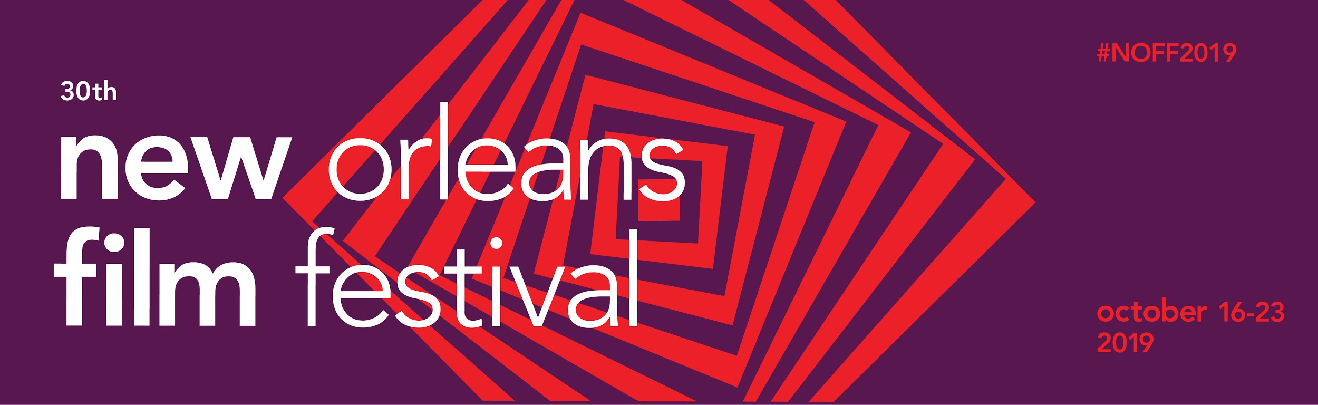

For Immediate Release
Thursday, May 30, 2018
Media Contact
Zaf Yumru
(504)-309-6633
zaf@neworleansfilmsociety.org

The New Orleans Film Festival Gears Up for 30th Anniversary
All-Access Passes are on Summer Pre-Sale

New Orleans, La. (September 19, 2018) –– The New Orleans Film Society (NOFS) unveiled the visual identity of the 30th annual New Orleans Film Festival which will be held October 16–23, 2019. All-Access Passes for the festival are now on Summer Pre-Sale with up to a $100 discount at neworleansfilmfestival.org

The festival’s 30th-anniversary look and feel, designed by New Orleans–based Maria Hinds Design Studio, visually captures the perspective shift experienced upon watching great cinema, with an emphasis on the festival’s success on discovering and showcasing exceptional new films to audiences from New Orleans and beyond.

“We’re really excited about this year’s festival art,” said Clint Bowie, Artistic Director of the New Orleans Film Society. “With its obvious reference to classic cinema design used in films like Hitchcock's Vertigo, the artwork speaks to the power of film to ensorcel an audience, drawing them deeper and deeper into a story and inviting reflection, engagement, and a reframing of preconceived notions. Great art absorbs you, and this design fully captures that.”
Over the past 10 years, the New Orleans Film Festival showcased over 60 Academy Award® nominees ahead of their nominations, including opening the festival with Best Picture winners in 2011 (The Artist), 2013 (12 Years a Slave), and 2019 (Greenbook). During this period, the festival debuted the work of over 2,000 emerging filmmakers whose distinctive voices are shaping the landscape of contemporary cinema.

In its 30-year history, the festival hosted world-renowned filmmakers like Steve McQueen, Agnieszka Holland, Julie Dash, D. A. Pennebaker, Peter Farrelly, Taylor Hackford, Rob Reiner, and acclaimed actors including Lupita N’yongo, Woody Harrelson, Jessica Biel, Joseph Gordon-Levitt, Patricia Clarkson, and Gabourey Sidibe.

On its 30th anniversary this October, the festival will bring 240+ films and over 500 filmmakers to New Orleans for 8 days. The Contemporary Arts Center will serve as the festival hub with two theaters, the main box office, a virtual reality exhibition, a bar, and more, and there will be film screenings around the city at the Prytania Theatre, The Broad Theater, Orpheum Theater, and The New Orleans Advocate.

Film and screenplay submissions for #NOFF2019 are open through June 21st, 2019 via neworleansfilmfestival.org. The full film and event lineup will be announced in mid-August.

#NOFF2019 PASSES ARE ON SUMMER PRE-SALE
All-Access Passes for the New Orleans Film Festival are on Summer Pre-Sale with $50 off of the regular price until July 9th, 2019 at neworleansfilmfestival.org.

This is the best time to join the New Orleans Film Society as a member to get an additional $50 off on All-Access Passes, for a total discount of $100, the deepest discount offered to members all year. Film Society members also get discounted and free tickets for year-round events, and receive a weekly newsletter with special deals on film events in New Orleans.

All-Access Pass holders enjoy free tickets to all screenings with priority entrance to theaters, access to parties every night of the festival, feel like a star at the Festival VIP Lounge, and more.

#NOFF2019 Weekender, Six Film, and Student Passes will be available later this Summer.

SUPPORT FOR THE 30TH NEW ORLEANS FILM FESTIVAL COMES FROM…
The 30th New Orleans Film Festival’s Marquee sponsors are New Orleans Tourism Marketing Corporation and Second Line Stages.

Chloe Wine Collection is the festival’s Official Wine Sponsor. The New Orleans Advocate is the festival’s Signature Media Sponsor. The Contemporary Arts Center of New Orleans is the Festival Hub Sponsor.

Producing and Premiere sponsors include the City of New Orleans, Cox Communications, The Helis Foundation, HBO, Louisiana Entertainment, NOLABA, Solomon Group, and VER.

Grantors include Bloomberg Philanthropies, Greater New Orleans Foundation, Jazz & Heritage Foundation, South Arts, and the National Endowment for the Arts. New Orleans Film Festival is supported in part by a grant from the Louisiana Division of the Arts, Office of Cultural Development, Department of Culture, Recreation & Tourism, in cooperation with the Louisiana State Arts Council, and the National Endowment for the Arts, a Federal agency.

ABOUT THE NEW ORLEANS FILM SOCIETY
The New Orleans Film Society discovers, cultivates, and amplifies diverse voices of filmmakers who tell the stories of our time. Founded in 1989, NOFS produces the Academy-accredited New Orleans Film Festival annually and invests year-round in building a vibrant film culture in the South to share transformative cinematic experiences with audiences, and connect dynamic filmmakers to career-advancing resources. Year-round programming includes free and low-cost screenings for members and the broader community of cinephiles in New Orleans, a 20-year running French Film Festival featuring contemporary and classic French cinema, and filmmaker professional development programs created to nurture diverse voices in filmmaking in the American South. NOFS is a 501(c)(3) organization.

NewOrleansFilmFestival.org

Instagram.com/NewOrleansFilmSociety
Facebook.com/NewOrleansFilmFestival
Twitter.com/NOFS

